# Content Planning Document for the Adidas Showcase

# Introduction

This document outlines the complete planning and functional integration strategy for the Adidas brand showcase within the Sports Warehouse website. It defines how banners, product cards, videos, and sidebar modules are orchestrated across gender-specific and unfiltered views, ensuring users experience Adidas through an immersive, brand-driven narrative. The showcase is organized around a rotating banner system that segments content by gender, age group, and stylistic identity — starting with menswear and transitioning into kids, unisex, and finally women’s collections. All elements are mapped to dynamic layout behaviour, bundle promotions, and media integration.

|  |  |
| --- | --- |
| **🧩** Banner Rotation & Grid System | **Layout for Adidas**  **Default Brand Page** |
| The first three banners (Urban Originals, Street Identity, Spider-Man) guide the user through Adidas' male-oriented lineup: one product set for men, one unisex streetwear set, and one heroic set for boys. All six product cards are shown in a shared 2×3 grid beneath these banners.  The switch occurs seamlessly when the **Creative Layers** banner appears—visually contrasting and bridging the earlier masculine and heroic tone with the bold, fashion-forward energy of the women’s section. Acting as a **thematic and visual pivot**, it refreshes the product grid with a new 2×3 layout that showcases Adidas' complete set of women's athleisure and performance items. |  |
|  |

## Adidas Product Grid

**Desktop Layout:** 7 columns × 2 rows under the hero banner

**Tablet:** 5 columns × 3 rows under the hero banner

**Items:**

### Poly Linear Full-Zip Hoodie + Pants (Steel Blue)

### 3-Stripes Running Tee (White)

### Originals: Campus 00s

### Marvel Spider-Man: Light-Up Trainers

### Marvel Spider-Man: Tracksuit (3-Stripes)

### Marvel Spider-Man: T-Shirt

### Marvel Spider-Man: Backpack

### Flared Leggings (3-Stripes)

### Tube Top (3-Stripes)

### Booty Shorts (3-Stripes)

### Hyperglam Long Sleeve Crop Top and Full-Length Leggings

### Powerreact Training Medium Support Sports Bra

### Powerreact Training Tights

### UEFA Euro16 Top Glider Ball

## Men – Urban

**Audience:**  
Men who want performance-inspired streetwear with a modern, city-edge.

### Hero Banner – Campus Sneakers

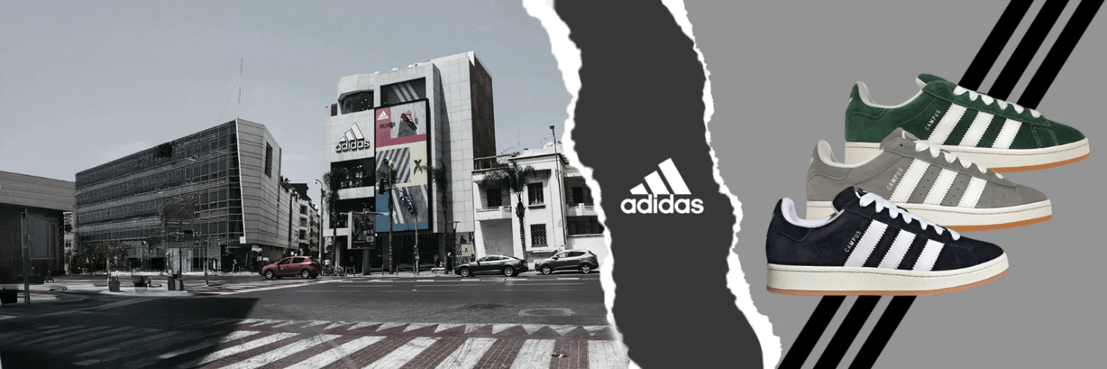

**Desktop/Tablet:** images/brands/adidas/banners/men/urban/01.png

#### ⧉ Sidebar & Video Integration (Men’s & Kids Sections)

|  |  |
| --- | --- |
| Behaviour  * **Video Module**:   + Shown whenever any Men/Kids banner (1–4) is active.   + Playback behaviour is based on user preference:   If the user opts into autoplay during the “Choose Your Style” popup, videos begin after 10 seconds on mute (desktop only).  Otherwise, user must tap ▶ to play manually.   * + When the user selects a women’s or kids’ Adidas product, the World Cup video is replaced with a corresponding sidebar video targeted at their demographic (e.g., Jennie video). * **Featured Product Panel**:   + Immediately beneath the video.   + On each banner rotation (or card hover/select), update image, title, teaser copy, and link text.   **Image:** images/brands/adidas/men/campus_sneakers/01.png    **Originals: Campus 00s** |  |

### Hero Banner – Urban Originals (Men)

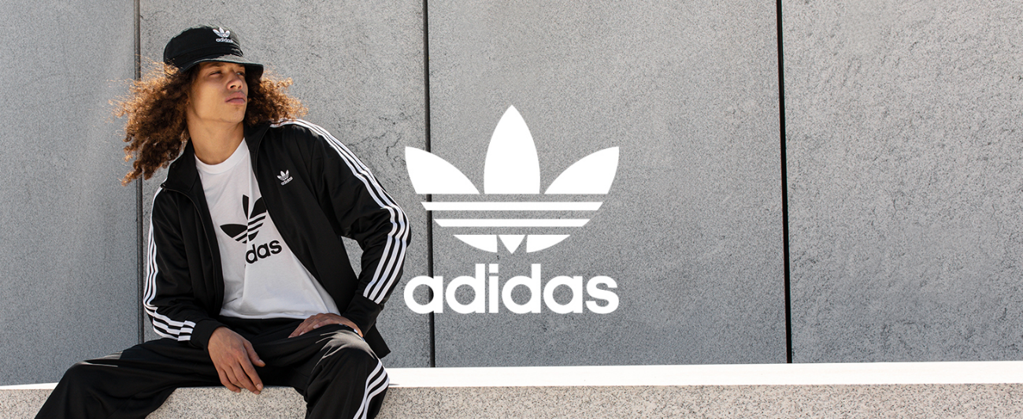

**Desktop/Tablet:** Desktop/Tablet: images/brands/adidas/banners/men/urban/02.png

**Placement & Behaviour:**

Appears second in the default sequence of Adidas banner rotation (2 of 10 total).

#### Sidebar

**Image:** images/brands/adidas/men/poly_linear_full_zip_hoodie_and_pants/01.png

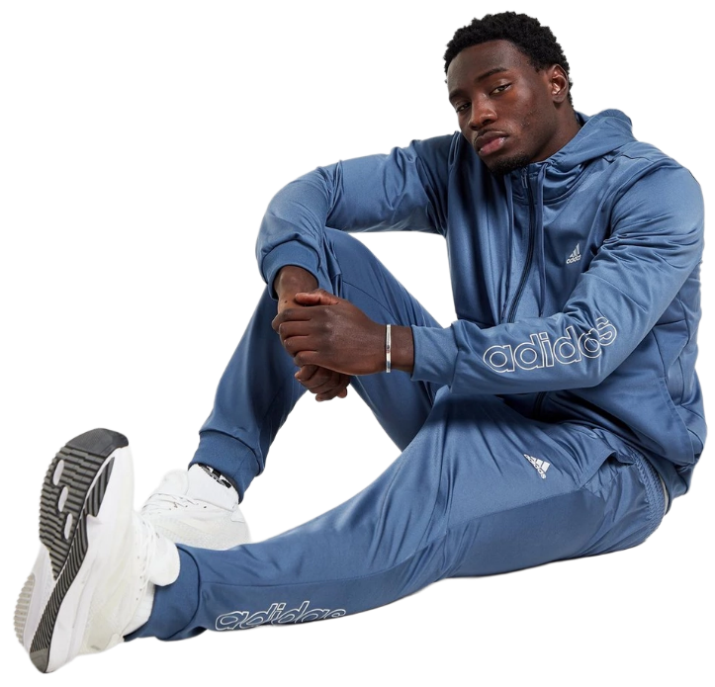

**Originals: Poly Linear Full-Zip Hoodie and Pants Tracksuit**

**Text:**

Step up your street style in this Adidas Poly Linear Tracksuit, combining a sleek full-zip hoodie with tapered pants for all-day comfort and movement. The shiny poly knit fabric offers a smooth, athletic finish, while bold linear adidas branding down the leg and sleeve makes a clean, confident statement whether you're warming up, working out, or chilling out.

##### Bundles & Pricing Logic

| **Bundle** | **Trigger** | **Discount** | **DB Flags** |
| --- | --- | --- | --- |
| Hoodie + Pants set | both SKUs added to cart | 30 % off | bundleEligible: true, bundleGroup: 'adidas-men-urban', |
|  |  |  | bundleRule: 'Hoodie + Pants → 30% off' |

**Analytics note:** Track “bundleApplied” events and compare average order value on bundle vs. single-item purchases.

### Hero Banner – Street Identity (Unisex)

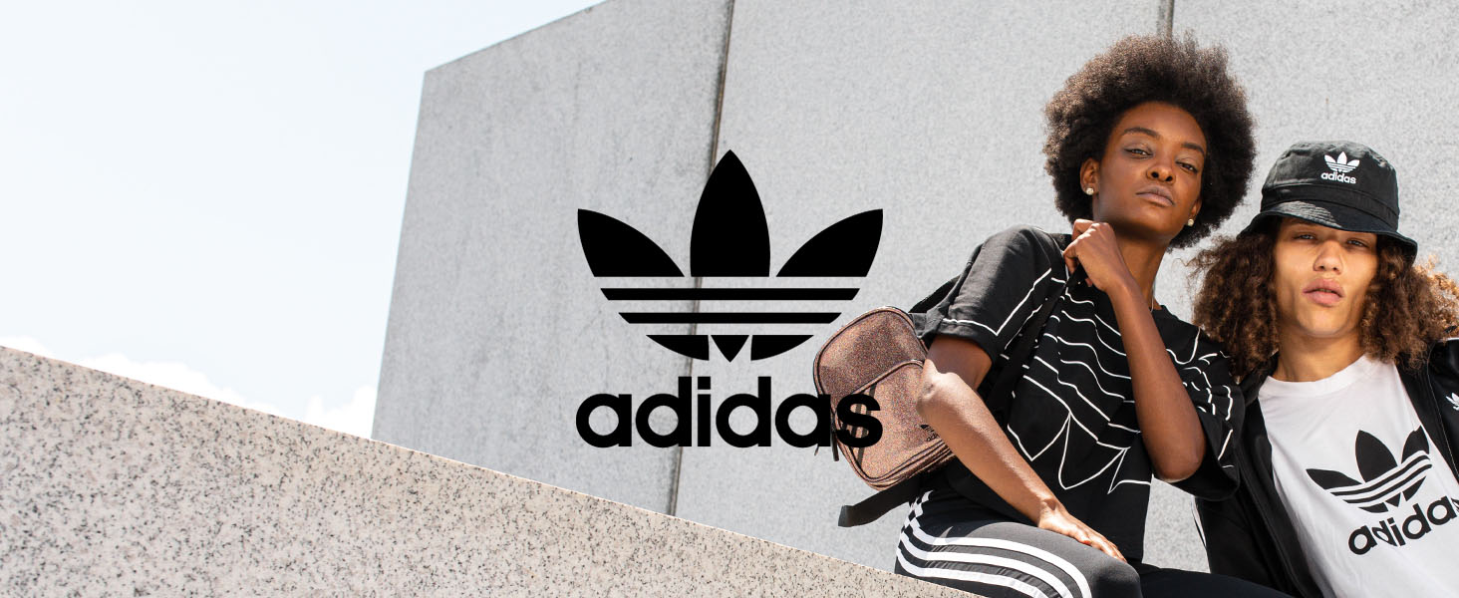

**Desktop/Tablet:** Desktop/Tablet: images/brands/adidas/banners/men/urban/02.png

**Placement & Behaviour:**

Appears third in the default sequence of Adidas banner rotation (3 of 10 total).

#### ⧉ Sidebar: Only a Different Product Image and Text

**Image:** images/adidas/men/3-stripes/01-running_tee.png

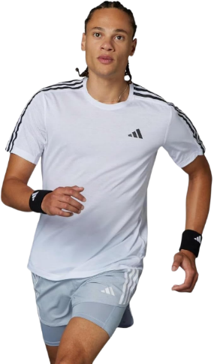

**Originals: Running Tee (3-Stripes)**

**Text:**

Stay cool, dry, and in motion with the Adidas 3-Stripes Running Tee. Lightweight and breathable with signature stripes down the shoulders, this performance tee is made for speed. Sweat-wicking AEROREADY fabric helps keep you focused from start to finish.

### Hero Banner – Marvel Spider-Man Outfit Collection (Kids)

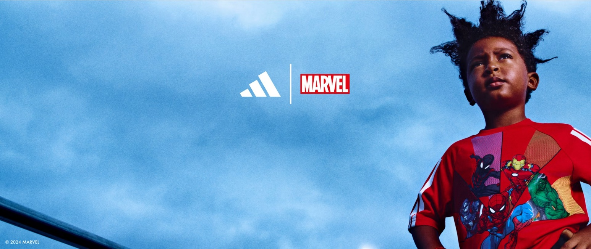

**Desktop/Tablet:** images/brands/adidas/kids/marvel-spider_man/banner/global_disney_marvel_superheroes-launch/01.png

**Placement & Behaviour:**

Appears fourth in the default sequence of Adidas banner rotation (4 of 10 total).

**2. Adidas Products (Kids)**

**Marvel Spider-Man Outfit Collection (Black)**

**Type:** Tracksuit, T-Shirt, Trainers, and Backpack  
**Gender:** Male

A complete, mix-and-match Marvel-themed set for kids featuring Adidas' 3-Stripes identity and superhero style.

**Special Offer:**  
Buy both the **Tracksuit** and **T-Shirt** and get **50% OFF** the **Light-Up Trainers** *and/or* **Backpack**. Complete the full heroic look at half the price—gear up and save big!

**a. Marvel Spider-Man: Tracksuit (3-Stripes) (Black)**

* Swing into action with the ultimate superhero outfit from adidas x Marvel. With slick Spidey graphics, smooth fabric, and matching top and pants, the tracksuit is perfect for play, sports, or showing off your superhero style all day long.

**📌 Notes:**

* Best for: Play, casual sports, themed events
* Pair it with the matching Spider-Man t-shirt, light-up trainers and backpack (sold separately) to complete the full heroic look.

**b. Marvel Spider-Man: T-Shirt (3-Stripes) (Black)**

* The adidas x Marvel Spider-Man t-shirt is bursting with color and comic book heroes. With Spidey, Iron Man, Hulk, and more all in one action-packed design, it’s perfect for kids who want to wear their favorite heroes with pride—on the playground or anywhere adventure calls.

**c. Marvel Spider-Man: Light-Up Trainers (3-Stripes) (Black)**

* Complete your superhero look with light-up Spider-Man trainers made for fun on the move. Featuring bold web graphics and bright flashing soles, these comfy kicks are built for playtime, running, and showing off your Spidey style with every step.

**📌 Notes:**

* Flashing soles add movement visibility
* Ideal for after-school play or themed dress-up
* Styled to match tracksuit and tee
* 50% off if purchased with tracksuit + tee

**Image:** images/brands/adidas/kids/marvel-spider_man/trainers-light_up/01.png

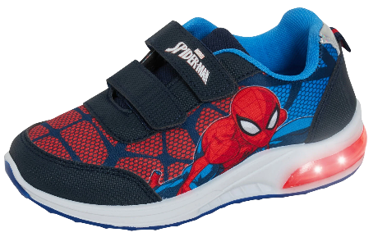

**Marvel Spider-Man: Light-Up Trainers (3-Stripes)**

#### ⧉ Sidebar & Video Integration (Men’s & Kids Sections)

|  |  |
| --- | --- |
| Behaviour This sidebar appears whenever the Marvel Spider-Man banner is active in the hero container, and displays a 2-image layout:   * **Top (horizontal image):** A campaign-branded visual showing a boy in Spider-Man apparel against a blue sky. Reinforces the Adidas x Marvel collaboration theme. * **Bottom (vertical image):** A portrait product image showing a boy and girl wearing the Tracksuit and T-Shirt. Serves as the visual anchor for the full 4-piece outfit narrative and is inclusive for girls.   **The sidebar text includes:**   * A short paragraph introducing the 4-piece set and highlighting the Spider-Man theme and 3-Stripes styling. * A **“Special Offer”** block summarizing bundle logic: *Buy the Tracksuit + Tee → get 50% off the Trainers and/or Backpack.* * **Hover behaviour:** Hovering a product card from this set replaces the lower image and text with that item’s content. * **Selection behaviour:** Selecting a product outside this set replaces both images and all sidebar text with the new product’s detail view. * **No autoplay video** is assigned to this banner. If a Marvel video is added later, it can replace the vertical image or appear in the top slot, following the same logic as the Men’s section. |  |

**d. Marvel Spider-Man: Backpack (3-Stripes) (Black)**

* Carry your gear with Spidey style in this compact adidas x Marvel backpack. With a bold Spider-Man patch, iconic 3-Stripes design, and just-right storage for school or adventure, it’s a practical way to complete the superhero set. Whether it’s books, snacks, or toys, this bag is made for kids on the go.

**📌 Notes:**

* Perfect add-on for the full Marvel outfit
* Makes the whole set school-ready
* 50% off if purchased with tracksuit + tee

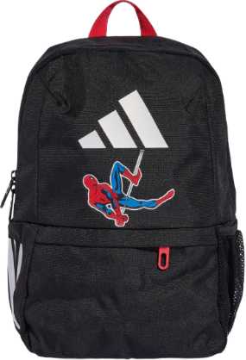

**Marvel Spider-Man: Backpack (3-Stripes)**

**🎯 Bundle Promotion Logic**

**Front-End Rule** (JS/PHP logic, not DB):

* Trigger bundle promotion when both:
  + Tracksuit
  + T-Shirt  
    are added to cart
* Automatically apply **50% discount** to:
  + Light-Up Trainers
  + Spider-Man Backpack

**Optional Database Flags** (optional for future dev):

* bundleEligible = TRUE (Tracksuit & T-Shirt)
* bundleDiscountItem = TRUE (Trainers & Backpack)
* bundleGroup = 'marvel-spiderman-set'

## Women – Athleisure & Performance Collections

**Audience:**  
Women and girls seeking bold, confident styles that fuse fashion, movement, and the 3-Stripes legacy.

### Hero Banner – Athleisure Part 1: Creative Layers

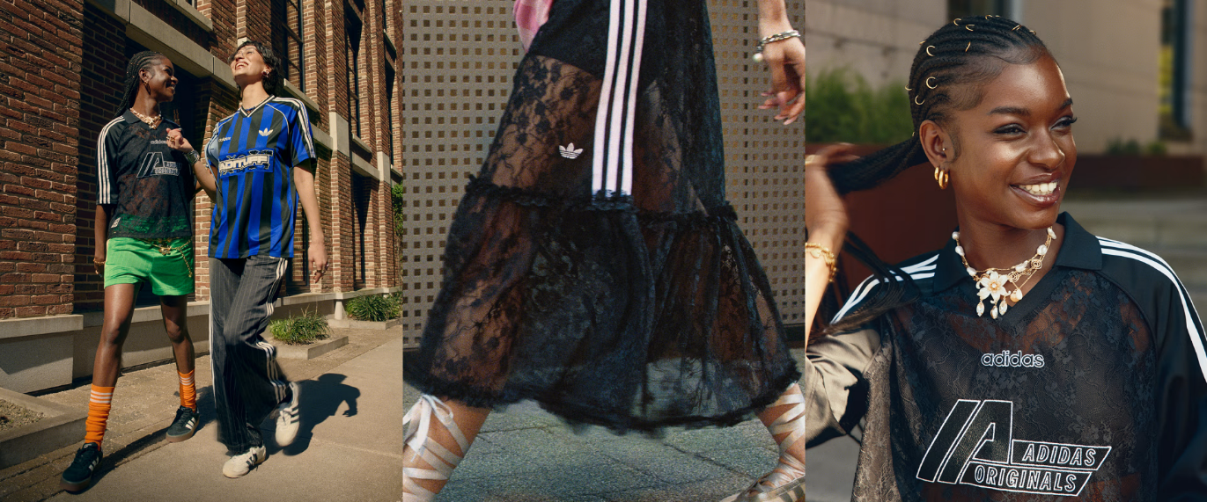

**Desktop/Tablet:** images/brands/adidas/banners/women/streetwear.png

*Text Beneath Banner*

Elevate your streetwear game with unexpected layers—sheer mesh skirts drape over 3-Stripes shorts, and cropped tube tops peek through graphic overlays. This editorial look fuses performance fabrics with high-fashion layering for a bold, rule-breaking vibe.

**📌 Notes:**

*For planning only—won’t appear on live site.*

* **Type:** Tube Top, Booty Shorts, Flared Leggings, Full-Zip Slim Top
* **Theme:** Creative layering—sheer mesh over street-ready basics
* **Target User:** Women and girls who mix high-fashion editorial styling with athletic performance.

*Behaviour*

* **No Sidebar:** This banner does not surface a sidebar; instead, the full-width 2×3 product grid sits directly beneath the hero image.
* **Product Grid:** On banner rotation, display the relevant Women’s Athleisure items in the expanded grid. Hover/select behaviour remains unchanged: hovering a card highlights it in the grid and updates any shared detail panel elsewhere on the page (if present)

### Hero Banner – Athleisure Part 2: Jennie Campaign (5 of 10)

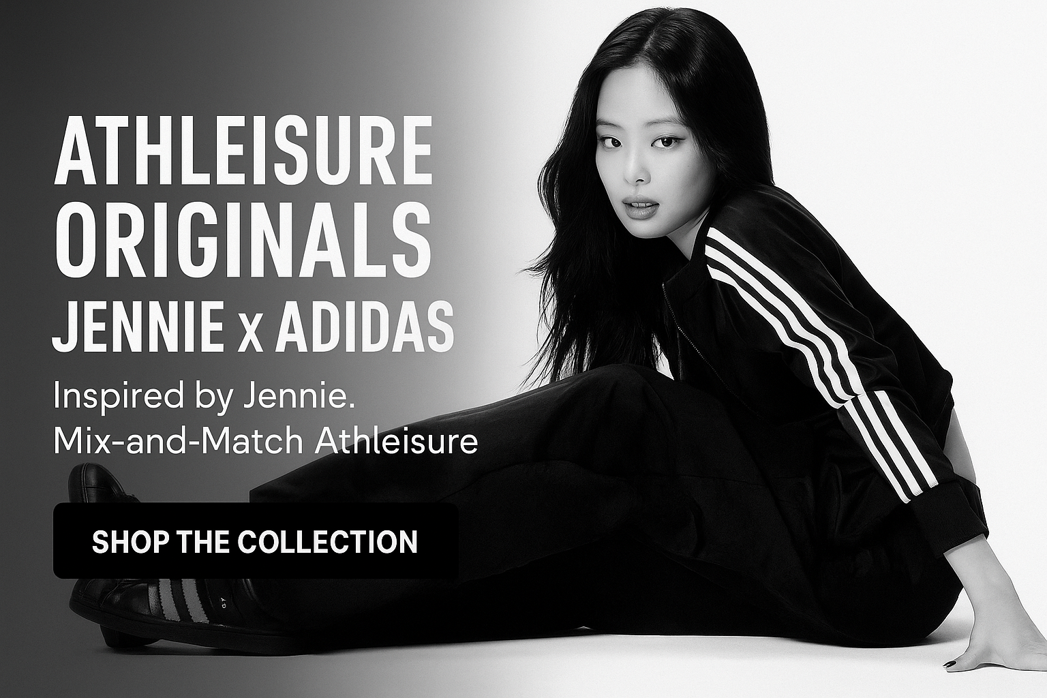

**Desktop/Tablet:** images/brands/adidas/banners/women/blackpink/jennie/superstar-the_original/06.png

**Type:** Tube Top, Booty Shorts, Flared Leggings, Full-Zip Slim Top

**Theme:** Style-forward activewear with a rebellious edge—more street than sport.  
**Target User:** Women and girls drawn to bold fashion statements, with optional coverage and confident bodywear pairing.

**Influencer:** South Korean K-Pop icon, Jennie from Blackpink.

**1. Tube Top (3-Stripes) (Black)**

* A sleek, strapless tube top with signature side stripes and cropped length. Worn alone or layered, the top delivers attitude in minimal fabric.

**📌 Notes:**

* Best for: Summer, dance rehearsal, layering under open jackets
* Wear it with the booty shorts for a head-turning combo
* Matches Jennie's all-black Adidas campaign look

**Image:** images/brands/adidas/women/3-stripes/tube_top/01.png

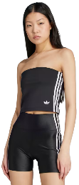

**Originals: Tube Top and Booty Shorts (3-Stripes)**

#### ⧉ Sidebar & Video Integration (Jennie X Adidas Originals)

|  |  |
| --- | --- |
| Text Beneath Banner This mix-and-match collection brings together bold silhouettes and nostalgic design. Whether daring or understated, the original 3-Stripes details and slick fabric finishes let you channel confidence your way—sexy, sporty, or somewhere in between. Whether styled for the city, a casual outing, or a performance look, this collection owns the intersection of athleisure and expression. Behaviour  * **Video Module**:   + **Primary Jennie Video:** Active when the Athleisure Part 1 “Jennie × Adidas Originals” banner becomes live. Playback follows user preference (autoplay muted after 10 s on desktop if enabled; otherwise, manual ▶️).   + **Second Video:** Immediately after (or on user toggle), the 13-second “Athleisure Fit” video plays in the same portrait slot. This clip highlights the tube top and shorts in motion—voice-over could be “Mix. Match. Move.” * **Image Slider for Jennie**:   + Immediately beneath the video, a 4-slide carousel displays images of Jennie modelling the clothes. * **Featured Product Panel**:   + A product carousel is beneath the video and image slider for Jennie.   + Users can navigate with left/right arrows; when autoplay is enabled, the slider advances every 5 s.   + On product‐card hover/select, the carousel pauses and immediately shows that product’s image in the same slot. |  |

**2. Booty Shorts (3-Stripes) (Black)**

* These high-rise satin-feel shorts cling confidently to the form, creating a bold streetwear edge. Not for the shy—but perfect for those who want to own the moment.

**📌 Notes:**

* Ideal for: Festivals, hot days, low-impact movement, dance, or Instagram-ready styling
* Pair with a crop top or flared leggings, a slim zip-up or oversized jacket

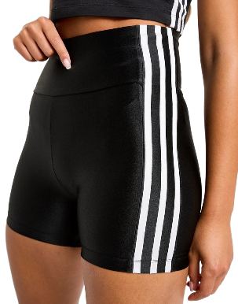

**Originals: Booty Shorts (3-Stripes)**

**3. Flared Leggings (3-Stripes) (Black)**

* Classic Adidas stripes meet retro energy in these full-length flared leggings. Hugging the thighs and opening at the calf, they bring movement, elegance, and just the right touch of throwback cool.

**📌 Notes:**

* Best for: Fashion-first casual wear, transitional outfits
* Ideal for those who want a confident shape without showing too much leg
* Style tip: can tone down a revealing top for a balanced look—or pair with a hoodie to subtly downplay the silhouette while still owning the look

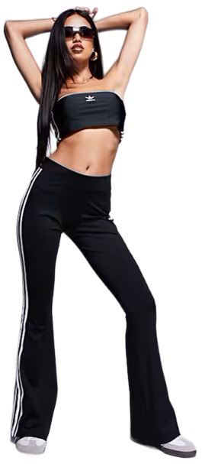

**Originals: Flared Leggings (3-Stripes)**

**4. Full-Zip Slim Top (3-Stripes) (Black)**

* This fitted jacket-style top is made from stretchy, sleek fabric that sculpts the body. A full-length zip makes it versatile—wear it zipped for coverage or open over a crop top for contrast.

**📌 Notes:**

* Best for: Layering, chill-weather athleisure, street-style edits
* Worn by models with the flared leggings for a complete retrofitted silhouette
* A confidence-booster for some, a low-key staple for others—this piece adapts to how much you want to stand out.

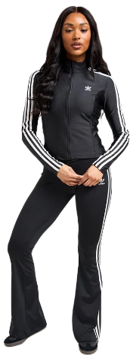

**Originals: Full-Zip Slim Top (3-Stripes)**

**🌟 Bonus Feature: Jennie from Blackpink**

In her iconic black-and-white Adidas Originals shoot, Jennie wore a styling almost identical to the tube top and flared leggings, layered with a full-zip top. While not an exact match, the pieces in this collection allow customers to recreate her look with ease—combining K-Pop fashion with Western flair.

### Hero Banner – Athleisure Part 3: Three Product Collage (5 of 10)



#### ⧉ Sidebar & Video Integration (Hyperglam Set)

|  |  |
| --- | --- |
| Text Beneath Banner Strike a balance between fierce and feminine in the Adidas Hyperglam set. The long sleeve crop top and high-rise leggings move with you—from studio to street—thanks to sleek performance fabric, sculpting seams, and a bold Hyperglam hue, available in black or mauve. Signature 3-Stripes details flash along the arms and hips, giving this look an edge that’s equal parts athletic and stylish.  **📌 Notes:**   * Best for: Yoga, pilates, dance, or high-energy movement * Sold as a set only * Midriff-baring top and curve-sculpted leggings for a coordinated silhouette  Behaviour  * **Featured Product Carousels**:   + A product carousel is beneath the video and image slider for Jennie.   + Users can navigate with left/right arrows; when autoplay is enabled, the slider advances every 5 s.   + On product‐card hover/select, the carousel pauses and immediately shows that product’s image in the same slot. |  |

**Desktop/Tablet:** images/brands/adidas/banners/women/blackpink/jennie/superstar-the_original/06.png

**🖤Hyperglam Long Sleeve Crop Top + Full-Length Leggings (3-Stripes)**

**Type:** Matching Set (not sold separately)

**Theme:** Feminine meets fierce—performance wear with a bold hue and contour-conscious design  
**Target User:** Women who want activewear that performs and turns heads — slim-fitting, supportive, and styled for both gym mirrors and selfies.

**Powerreact Training Bra + Tights (3-Stripes) (Black)**

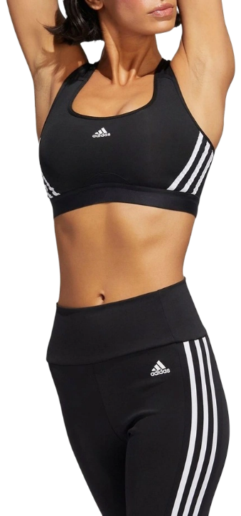

**Originals: Training Bra + Tights (3-Stripes)**

**Type:** Sports Bra + Tights (Sold separately or together at a 25% discount on both items when bought as a pair.)

**Theme:** High-performance activewear with iconic styling  
**Target User:** Women who want gym-ready function with timeless Adidas edge.

💬 Own your strength in this iconic black-on-black Adidas training set. The Powerreact sports bra delivers medium support with a racerback cut and mesh back panel for breathability, while the matching 3-Stripes tights hug your body with a high-rise waist and full-length coverage. Whether you're at the gym or in the zone at home, the classic 3-Stripes branding gives you timeless athletic style with performance to match. Wear them together and feel powerful, streamlined, and ready to move.

**📌 Notes:**

* Bra: Medium support, breathable mesh panel, suitable for cardio and strength training
* Tights: High-rise waistband, full-length fit for performance and mobility
* Buy separately or together at a discounted bundle price
* Classic Adidas look, versatile enough for gym, lounge, or errands

1. **Sidebar Bundle Promo Message Block (All Sets):**
   * Athleisure, Powerreact and Hyperglam sets now come with bundle rewards:
   * Buy 2 = 25% off both
   * Buy 3 = 50% off the third
   * Buy 4 = 50% off both third and fourth items
   * **Note:** Though sold as a single set, the Hyperglam top and leggings count as two qualifying items for bundle promotions.
2. **Product Cards Displayed in a Fixed 2x3 Grid**

* Tube Top
* Booty Shorts
* Flared Leggings
* Full-Zip Slim Top
* Hyperglam Set
* Powerreact Set (Bra + Tights)

Each product card includes:

* + Product Name
  + First image displayed in image string
  + Price (incl. sales price, if applicable)

**🎯 Bundle Promotion Logic**

**Front-End Rule (JS/PHP logic, not DB):**  
**• Universal Adidas Women’s Bundle Logic:**  
Applies across the **Athleisure**, **Powerreact**, and **Hyperglam** sets (Hyperglam counts as two items):

1. **Buy any 2 items** from the same set → apply **25% discount** to both items
2. **Buy 3 items** → apply **50% discount** to the third item
3. **Buy 4 items** → apply **50% discount** to both the third and fourth items

**• Set Definitions:**

* **Athleisure Set:** Tube Top, Booty Shorts, Flared Leggings, Slim Zip Top
* **Powerreact Set:** Powerreact Bra + Powerreact Tights
* **Hyperglam Set:** Crop Top + Leggings (sold as one set, but counted as two items)

**Optional Database Flags (for future dev):**

* bundleEligible = TRUE (for all 6 Adidas women’s items)
* bundleGroup = 'adidas-women-athleisure', 'adidas-women-powerreact', 'adidas-women-hyperglam'
* bundleRule = 'Buy 2, 25% off both; Buy 3, 50% off third; Buy 4, 50% off third & fourth'